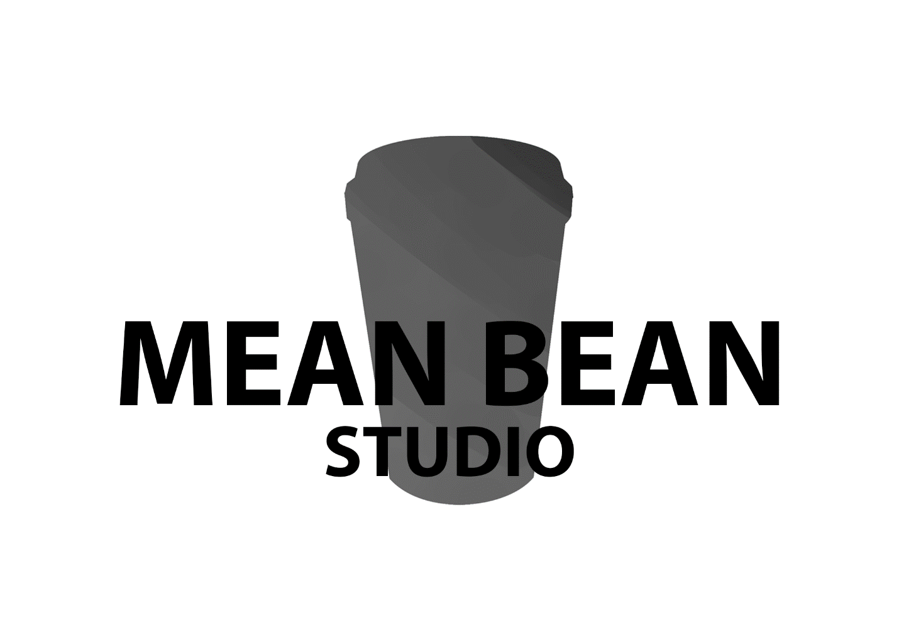

Coffee-mania

Luke, Will, Aiden, Domenic, Pasqual, Tarek

**Project overview**

Coffee-mania is a 3d endless runner. The game allows the players to earn real life rewards. There are two ways to earn the rewards;

1. Spend currency collect in the game to purchase discounts
2. Get a high enough score to earn a hefty discount or even free coffee.

The Team

Aiden: environmental artist and lead artist

Luke: Lead designer

Domenic: Character artist

Tarek: animator

Will: Lead programmer

Pascal:

**Confirmed Project**

The confirmed proposal was our game Coffee-mania. This game is was pitched as an endless runner that allows the player to earn real life rewards.

**Client feedback and response**

Client feedback

* Ideas to the game are too simple
* Don’t consider mobile, just do pc or mobile not both
* Define the art style more
  + Make it very clear what we’re looking at
* Hand painted doesn’t work with PPR
* Mobile building could be very challenging
* May be problematic to do a mobile game, art and programming will be affected

Our response

* We ditched the phone idea and are going to make the game on Pc only. This fixes most issues.
* We went for a stylised art style and ditched the hand painted PBR
* We have also expanded upon our art style and gameplay
  + We made our art style clearer and to show what we wanted. We did this by getting more specific pictures and have arrows pointing gout what we wanted
  + We expanded our gameplay and defined in a clear way to show there was more to it.

**Project schedule**

Milestone 1: 5th of Nov

* By this milestone the game should be in alpha state
* All mechanics and core game features should be implemented and working to show the client.
* Talk to the client about the rewards for the top players on the leaderboard.

Milestone 2: 19th of Nov

* The game should be in a beta state
* Focus on tweaking values
* All assets should be implemented and be in a tweaking state.
* Polish should commence in the week following this milestone

Milestone 3: 27th of Nov

* The game should be complete.
* Everything should have been polished in the previous 2 weeks before completion

**Asset list**

Art assets

* Background img-**Mountains**
* Background img-**Desert**
* Foliage-**Mountain** x2
* Foliage-**Desert** x2
* Rock-**Mountain** x2
* Rock-**Desert** x2
* Ground plane-**Mountain**
* Ground plane-**Desert**
* Mountain-**Mountain**
* Hill-**Desert**
* Tree-**Mountain**
* Tree-**Desert**
* Bricks-**Mountains**
* Bricks-**Desert**
* Wooden plank x2
* Character assets

Scripts

* Map generation
* Movement (strafing, jumping, sliding etc)
* Item pickups (milk, barista knife, net, see GDD mechanics)
* Currency
* Leaderboards
* Screen/level manager

Sounds

* Chasing music (royalty free)
* Generic jumping sounds
* Coffee grinder sounds
* Character sounds (grunts when jumping)

Animations

* Character- running
* Character- collision
* Bad guy- run
* Bad guy- catch

**Budget summary**

$4,900 per artist for the whole project

$5,440 per programmer for the whole project

$5,120 per designer for the whole project

3 artists

2 programmers

1 Designer.

* Team cost: $30,700
* Maya 2 months: $1,620
* Z brush 2 months: $240
* Substance indi license 2 months: $120
* Photoshop 2 months: $86
* Unity pro X6 2 months: $1500
* Programs/ tools: $3,566 (for 2 months)
* **Total: $34,266**

**Risk assessment.**

* **Potential money pit for the client**:
  + Because of the rewards given in out by the game it could be a potential money pit
  + There needs to be clear communication between the developers and the client so that this does not become a problem.
    - Risk severity: 2D(low)
* **Map Generation:**
  + this is the bread and butter for the game, our programmers haven’t had much experience in this field
  + To lower this risk Getting the generation working as intended may take some time. We have the programmers working on this first.
  + Risk severity: 3C(medium)